**Google Analytics Assignment 2 – Attribution Modeling**

**Author: Karan Ashok**

Date Range: April 12, 2017 to April 18, 2017

1. What % of conversions were click assisted? Total – direct (mcf) Number of click assisted conversions: 1888

Total number of conversions: 4339

% of conversions that were click assisted: 43.51%

2. What three channels represented the largest % of conversions (list the % for each of the three)?

*Table 1: Channels representing largest % of conversions*

|  |  |
| --- | --- |
| Channel | % of conversions |
| 1. Direct | 52.98 |
| 2. Referral | 46.07 |
| 3. Organic search | 27.79 |

3. What % of conversions combined direct, referral, and organic search?

1.89% (82 conversions in total)

4. Which channels tend to initiate a sales cycle?

First Interaction Channels (In the example, these are Direct, Referral & Organic search)

5. Which channels tend to close a sales cycle?

Last Interaction Channels (In the example, these are Direct, Referral & Organic search)

6. Which channels tend to most interact with the sales cycle prior to buying?

According to the Multi-Channel Funnel’s Top Conversion Path report, it is clear that Direct, Referrals, and Organic Search channels are the ones that interact most with the sales cycle prior to buying. We can see that in the top 10 conversion paths, the above-mentioned channels are most frequent.

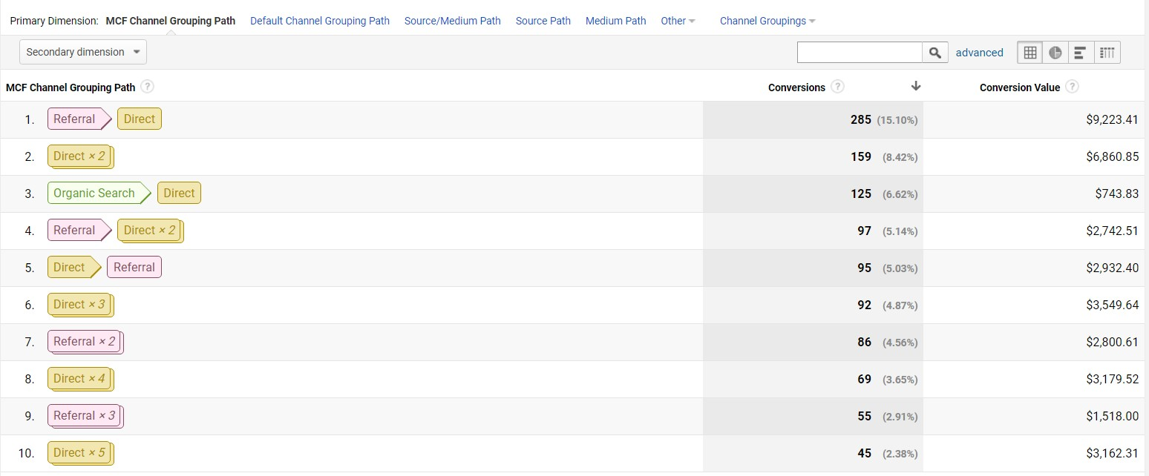

*Figure 2: MCF's Top Conversion Path report*

7. How many days does it take to convert for the various goals that the firm has? Report the average and the mode.

*Table 2: Most likely number of days to convert various goals*

|  |  |  |
| --- | --- | --- |
| Goal | Most likely number of days taken  to achieve goal | Percentage of conversions on the  most likely day (previous column) |
| 1. Purchase completed | 0 (same day) | 63.91 |
| 2. Engaged users | 0 (same day) | 75.62 |
| 3. Registrations | 0 (same day) | 87.36 |
| 4. Entered checkout | 0 (same day) | 68.41 |
| 5. Smart Goals | 0 (same day) | 58.02 |

The mode for the number of days to convert various goals is 0 days, i.e. the conversion takes place the same day without any lag in the number of days.

To calculate the average number of days to reach a conversion, we consider the following:

|  |  |
| --- | --- |
| **Time Lag in Days** | **Number of Conversions** |
| 0 | 2777 |
| 1 | 98 |
| 2 | 72 |
| 3 | 45 |
| 4 | 54 |
| 5 | 39 |
| 6 | 38 |
| 7 | 39 |
| 8 | 24 |

|  |  |
| --- | --- |
| 9 | 18 |
| 10 | 37 |
| 11 | 14 |
| 12-30 | 553 |
| Total Number of Conversions: | **3808** |

*Table 3: Time Lag in Days for conversion for all goals*

Using Table 3, average number of days for a conversion

= Weighted sum of conversions/ Total number of conversion

= (0 + 98 + 144 + 135 + 216 + 195 + 228 + 273 + 162 + 370 + 154 + 11613)/3808

= 13588/3808

= 3.5

Hence, using the Weighted Average Mean method, we obtain the average number of days to finalize a conversion: **3.5 days**

8. Which conversions take longer and which conversions take shorter in terms of number of days?

Referring to Table 2, the goals, which have a higher percentage of conversions on the same day, tend to take less time to complete. Hence goals pertaining to have shorter conversion times:

a. Engaged users, and b. Registrations.

On the other hand, the following goals take longer to convert:

a. Smart Goals

b. Purchase completed c. Entered checkout

9. How many times did customers interact with each channel component prior to converting? Report the average and the mode for each firm goal.

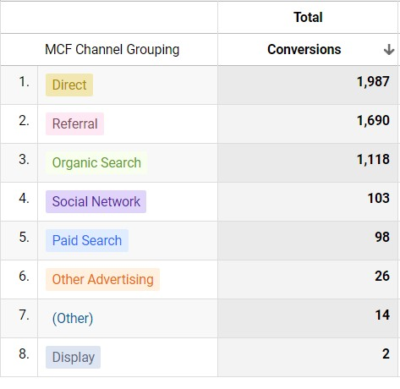

*Figure 3: Total number of interaction per channel in terms of number of conversions*

Breaking down on a per-goal basis:

|  |  |  |  |  |
| --- | --- | --- | --- | --- |
|  | Goal 1:  Purchase completed |  |  |  |
| Channels: | First Click | Assisted Click | Last Click | **Total** |
| Referral | 256 | 150 | 199 | 605 |
| Direct | 181 | 184 | 277 | 642 |
| Organic Search | 76 | 43 | 47 | 166 |
| Paid Search | 7 | 6 | 9 | 22 |
| Social network | 2 | 1 | 3 | 6 |
| Other | 1 | - | 1 | 2 |
| Other Advertising | - | - | - | 0 |

|  |  |  |  |  |
| --- | --- | --- | --- | --- |
|  | Goal 2:  Engaged  Users |  |  |  |
| Channels | First Click | Assisted Click | Last Click | **Total** |
| Referral | 494 | 249 | 397 | 1140 |

|  |  |  |  |  |
| --- | --- | --- | --- | --- |
| Direct | 495 | 382 | 700 | 1577 |
| Organic Search | 578 | 160 | 475 | 1213 |
| Paid Search | 38 | 21 | 35 | 94 |
| Social network | 36 | 16 | 31 | 83 |
| Other | 2 | 1 | 8 | 11 |
| Other Advertising | 10 | 3 | 7 | 20 |

|  |  |  |  |  |
| --- | --- | --- | --- | --- |
|  | Goal 3:  Registration |  |  |  |
| Channels | First Click | Assisted Click | Last Click | **Total** |
| Referral | 178 | 56 | 163 | 397 |
| Direct | 164 | 73 | 207 | 444 |
| Organic Search | 159 | 42 | 134 | 335 |
| Paid Search | 8 | 5 | 6 | 19 |
| Social network | 19 | 7 | 17 | 43 |
| Other | 1 | 0 | 1 | 2 |
| Other Advertising | 9 | 1 | 10 | 20 |

|  |  |  |  |  |
| --- | --- | --- | --- | --- |
|  | Goal 4:  Entered  Checkout |  |  |  |
| Channels | First Click | Assisted Click | Last Click | **Total** |
| Referral | 354 | 201 | 268 | 823 |
| Direct | 283 | 261 | 424 | 968 |
| Organic Search | 171 | 82 | 119 | 372 |
| Paid Search | 11 | 10 | 11 | 32 |
| Social network | 20 | 10 | 18 | 48 |
| Other | 1 | 0 | 2 | 3 |
| Other  Advertising | 1 | 2 | 0 | 3 |

|  |  |  |  |  |
| --- | --- | --- | --- | --- |
|  | Goal 5:  Smart  Goals |  |  |  |
| Channels | First Click | Assisted Click | Last Click | **Total** |
| Referral | 126 | 114 | 83 | 323 |
| Direct | 82 | 112 | 147 | 341 |
| Organic Search | 22 | 28 | 3 | 53 |
| Paid Search | 6 | 6 | 5 | 17 |
| Social network | 4 | 3 | 3 | 10 |
| Other | 0 | - | 1 | 1 |

|  |  |  |  |  |
| --- | --- | --- | --- | --- |
| Other  Advertising | 3 | 2 | 1 | 6 |

10. What were the three most likely conversion paths for each conversion?

For all goals together, the following are the three most likely paths:

*Figure 4: Three most likely conversion paths for all goals*

For Goal 1: Purchase completed,

*Figure 5: Three most likely conversion paths for Goal 1*

For Goal 2: Engaged Users,

For Goal 3: Registrations,

*Figure 6: Three most likely conversion paths for Goal 2*

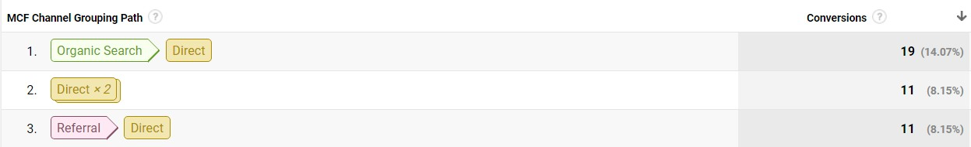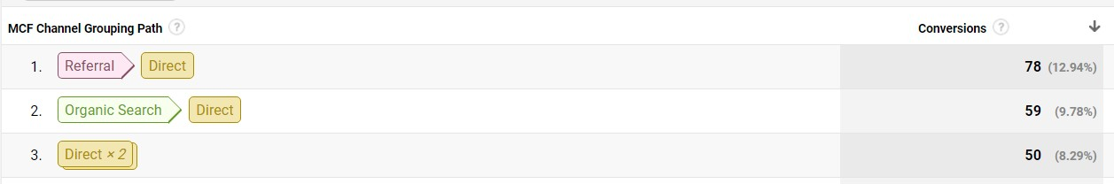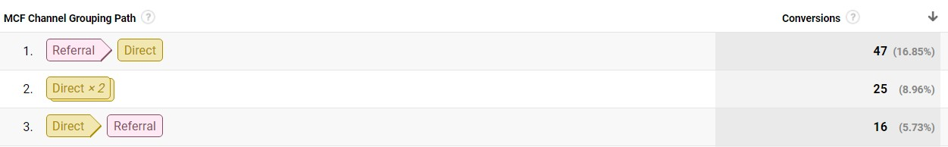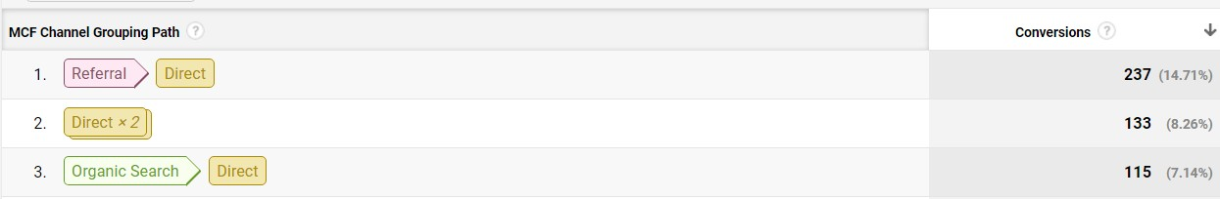

*Figure 7: Three most likely conversion paths for Goal 3*

For Goal 4: Entered Checkout,

For Goal 5: Smart Goals,

*Figure 8: Three most likely conversion paths for Goal 4*

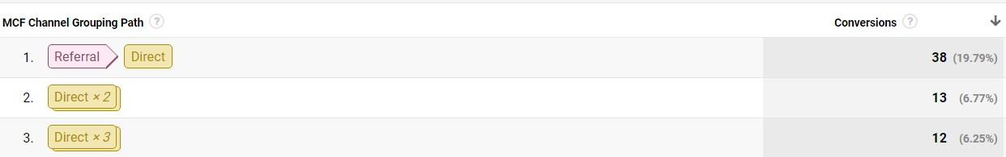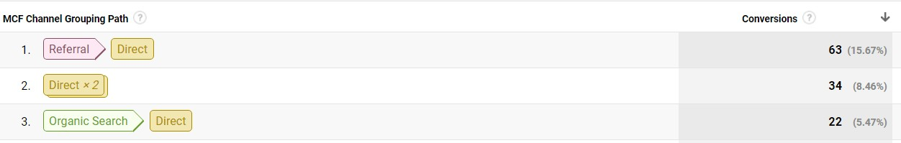

*Figure 9: Three most likely conversion paths for Goal 5*

11. How often did each channel initiate, assist, and close conversions for each firm goal?

Channels:

|  |  |  |  |
| --- | --- | --- | --- |
|  | Goal 1: Purchase completed | | |
| First Click | Assisted Click | Last Click |
| Referral | 256 | 150 | 199 |
| Direct | 181 | 184 | 277 |
| Organic Search | 76 | 43 | 47 |
| Paid Search | 7 | 6 | 9 |
| Social network | 2 | 1 | 3 |
| Other | 1 | - | 1 |
| Other Advertising | - | - | - |

|  |  |  |  |
| --- | --- | --- | --- |
|  | Goal 2: Engaged Users | | |
| Channels | First Click | Assisted Click | Last Click |
| Referral | 494 | 249 | 397 |
| Direct | 495 | 382 | 700 |
| Organic Search | 578 | 160 | 475 |
| Paid Search | 38 | 21 | 35 |
| Social network | 36 | 16 | 31 |
| Other | 2 | 1 | 8 |
| Other Advertising | 10 | 3 | 7 |

|  |  |  |  |
| --- | --- | --- | --- |
|  | Goal 3: Registration | | |
| Channels | First Click | Assisted Click | Last Click |
| Referral | 178 | 56 | 163 |
| Direct | 164 | 73 | 207 |
| Organic Search | 159 | 42 | 134 |

|  |  |  |  |
| --- | --- | --- | --- |
| Paid Search | 8 | 5 | 6 |
| Social network | 19 | 7 | 17 |
| Other | 1 | 0 | 1 |
| Other Advertising | 9 | 1 | 10 |

|  |  |  |  |
| --- | --- | --- | --- |
|  | Goal 4: Entered Checkout | | |
| Channels | First Click | Assisted Click | Last Click |
| Referral | 354 | 201 | 268 |
| Direct | 283 | 261 | 424 |
| Organic Search | 171 | 82 | 119 |
| Paid Search | 11 | 10 | 11 |
| Social network | 20 | 10 | 18 |
| Other | 1 | 0 | 2 |
| Other  Advertising | 1 | 2 | 0 |

|  |  |  |  |
| --- | --- | --- | --- |
|  | Goal 5: Smart Goals | | |
| Channels | First Click | Assisted Click | Last Click |
| Referral | 126 | 114 | 83 |
| Direct | 82 | 112 | 147 |
| Organic Search | 22 | 28 | 3 |
| Paid Search | 6 | 6 | 5 |
| Social network | 4 | 3 | 3 |
| Other | 0 | - | 1 |
| Other  Advertising | 3 | 2 | 1 |

12. Utilize the default models section of the Attribution Report Model Comparison tool and analyze important differences across the seven models provided.

a. Comparison of Last Interaction model and Last Non-Direct-Click i. For Direct, Conversions decrease by 48.16%

ii. For all other channels, there is an increase in conversions. The highest increase is for

Referral by 51.11%.

b. Comparison of Last Interaction model and Last AdWords lick i. For Paid Search, conversions increase by 52.46%.

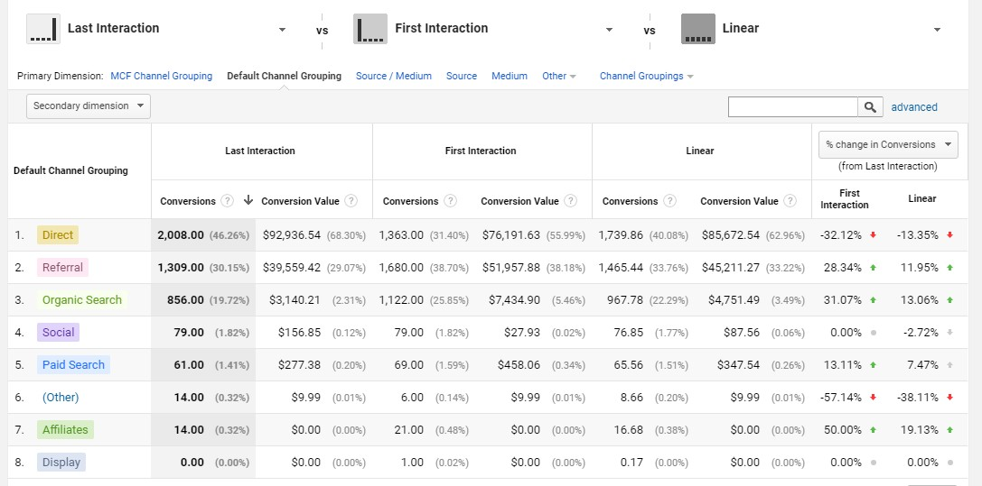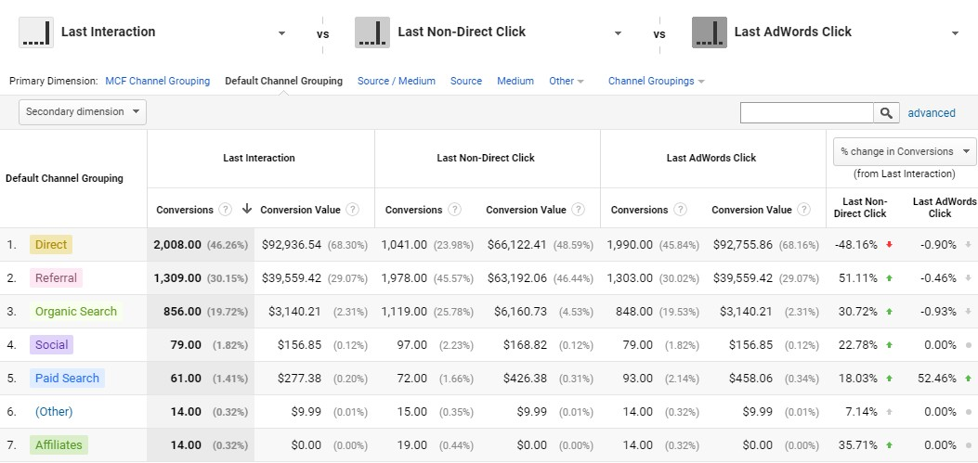

c. Comparison of Last Interaction model and First Interaction and Linear

i. The conversions (percentage) decreases for Direct and other channels. ii. The conversions (percentage) increases for rest of the channels.

d. Comparison of Last Interaction model and Time Decay and Position Based

i. The conversions (percentage) decreases for Direct and other channels. ii. The conversions (percentage) increases for rest of the channels.

